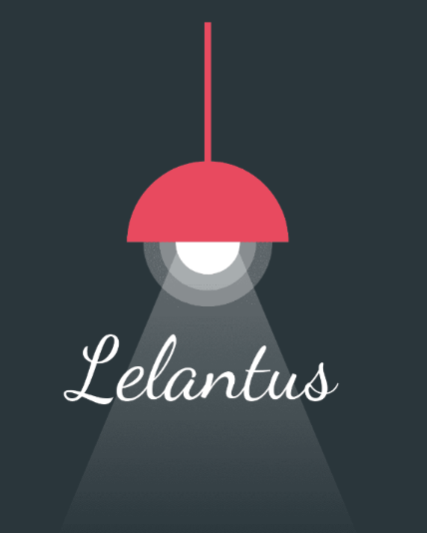

Lelantus is a wearable designed to protect you against harassment

Enlighten the darkness

**SOLUTION**

**Wearable** easy to wear and use

**Instant** notifications

**Help** in the identification process



**PROBLEM**

**Information** of harassment cases worldwide

**High** numberof deaths

**Late** reaction against cases





**How Lelantus work?**

Lelantus is a **wearable** that records audio and video when it is

activated. It also **communicates** position and emits loud noise

when the **panic mechanism** is activated. The recorded

information is sent to Microsoft Azure, where two different backends exists,

the user one and the authorities interface.

blabla bla bla bla bla bla bla bla bla bla bla bla bla bla a bla bla bla bla bla bla:



**Components:** Microphone, speaker, GPS, camera, network connection

**Defence mechanisms:** Panic mechanism, break alarm

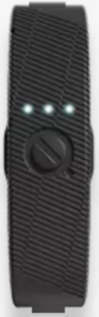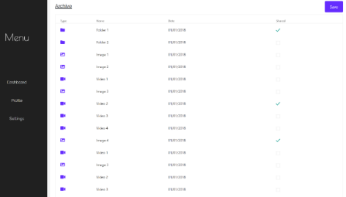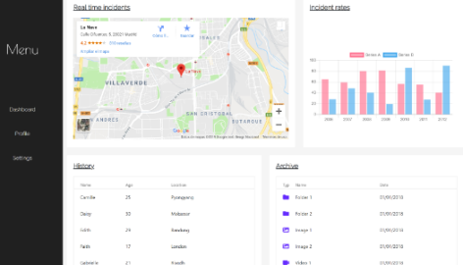

**Prototype:** [**http://lelantus.azurewebsites.net/**](http://lelantus.azurewebsites.net/)



**Filip Finfando**

Data scientist - Marketing

**Panagiotis Michalopoulos**

Computer Engineer -

IOT Expert

**Javier de la Rúa**

Computer Engineer - Developer

**Daniel Mínguez**

Data scientist –

Streaming Analytics



**User Interface:** The user can manage the information recorded

**Authorities interface:** Alarms are visible as well as statistics